Lab 3

Lab 2 Buffer - Schematic and Simulation

Ezra Senanu

5/10/2024

ECEN 250

**Objectives**

In this lab we tried to find the errors from the previous lab and correct them. Since this is a continuation of the previous lab, we duplicated the lab because of all the changes we will make. We made some constrains and clearances that complied with PCB design rules. We did a lot of placements and routing of the circuit design. We also created a ground plane. We manufactured Gerber and NC drill files. We eventually verified the drill and Gerber files and uploaded them into JLCPCB to make sure it works.

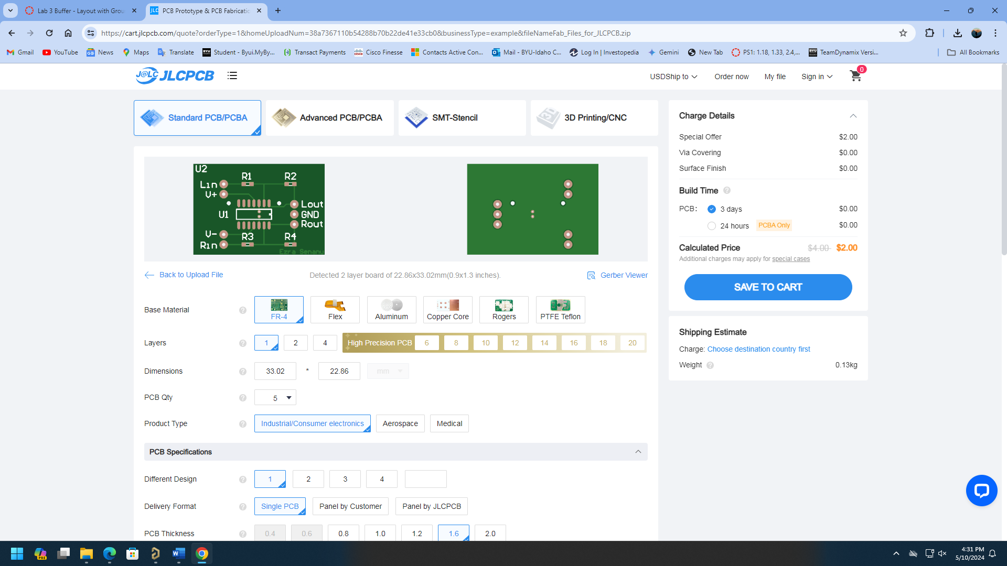

Paste a copy of lab  